 | Testing and Training Center of Farm Machinery  Department of Farm Machinery and Power Engineering  College of Agricultural Engineering and Technology  Junagadh Agricultural University  JUNAGADH – 362 001 (GUJARAT) | 
P | Phone : (0285) 2672080-90, Ext. 390 & 484; Fax : (0285) 2671018

SPECIFICATION SHEET OF TRACTOR OPERATED POWER SPRAYER

1 | General
 | a) | Name |  |  |  |  | :
 | b) | Type |  |  |  |  | :
 | c) | Make |  |  |  |  | :
 | d) | Name of manufacturer |  |  |  |  | :
 | e) | Name of applicant |  |  |  |  | :
 | f) | Selling price in India |  |  |  |  | :
 | g) | Serial Number |  |  |  |  | :
 | h) | Model |  |  |  |  | :
 | i) | Size (mm) |  |  |  |  | :
 | j) | Suction capacity (lit/min) |  |  |  |  | :
 | k) | Year of manufacture |  |  |  |  | :
 | l) | Recommended source of power as per applicant |  |  |  |  | :
2 | Constructional Details
2.1 | Main frame / Chassis:
 | a) |  | Type and material |  |  |  |  |  | :
 | b) |  | Size of material (mm) |  |  |  |  |  | :
 | c) |  | Overall size (mm) |  |  |  |  |  | :
2.2 | Pump:
 | a) |  | Type, make and model |  |  |  |  |  | :
 | b) |  | No. of piston or plunger |  |  |  |  |  | :
 | c) |  | Inner dia. and stroke length of piston or plunger (mm) |  |  |  |  |  | :
 | d) |  | Recommended pump speed for spraying (rpm) |  |  |  |  |  | :
 | e) |  | Suction volume (l/min) |  |  |  |  |  | :
 | f) |  | Max. achievable pressure (bar) |  |  |  |  |  | :
 | g) |  | Pressure gauge capacity (bar) |  |  |  |  |  | :
 | h) |  | Pump power requirement (kW) |  |  |  |  |  | :
 | i) |  | Pump weight (kg)
2.3 | Spray gun:
 | a) |  | Make and model |  |  |  |  |  | :
 | b) |  | Length of gun (mm) |  |  |  |  |  | :
 | c) |  | No. and type of nozzle provided on gun |  |  |  |  |  | :
2.4 | Tank:
 | a) |  | Make and model |  |  |  |  |  | :
 | b) |  | Material |  |  |  |  |  | :
 | c) |  | Capacity (l) |  |  |  |  |  | :
 | d) |  | Overall size (mm) |  |  |  |  |  | :
2.5 | Agitating device |  |  |  |  |  |  |  | :
2.6 | Mechanism for Auto reel for spray pipe/delivery hose:
 | a) |  | Type and material |  |  |  |  |  | :
 | b) |  | Size of material used (mm) |  |  |  |  |  | :
 | c) |  | Size of reel (mm) |  |  |  |  |  | :
 | d) |  | Method of power transmission to this mechanism |  |  |  |  |  | :
 | e) |  | Capacity of reel (m) |  |  |  |  |  | :
2.7 | Spray pipe/delivery hose:
 | a) |  | Type and material |  |  |  |  |  | :
 | b) |  | Length (m) and dia. of pipe (mm) |  |  |  |  |  | :
2.8 | Type of hitch and its details :
 | a) |  |  | Type | :
 | b) |  |  | Constructional details | :
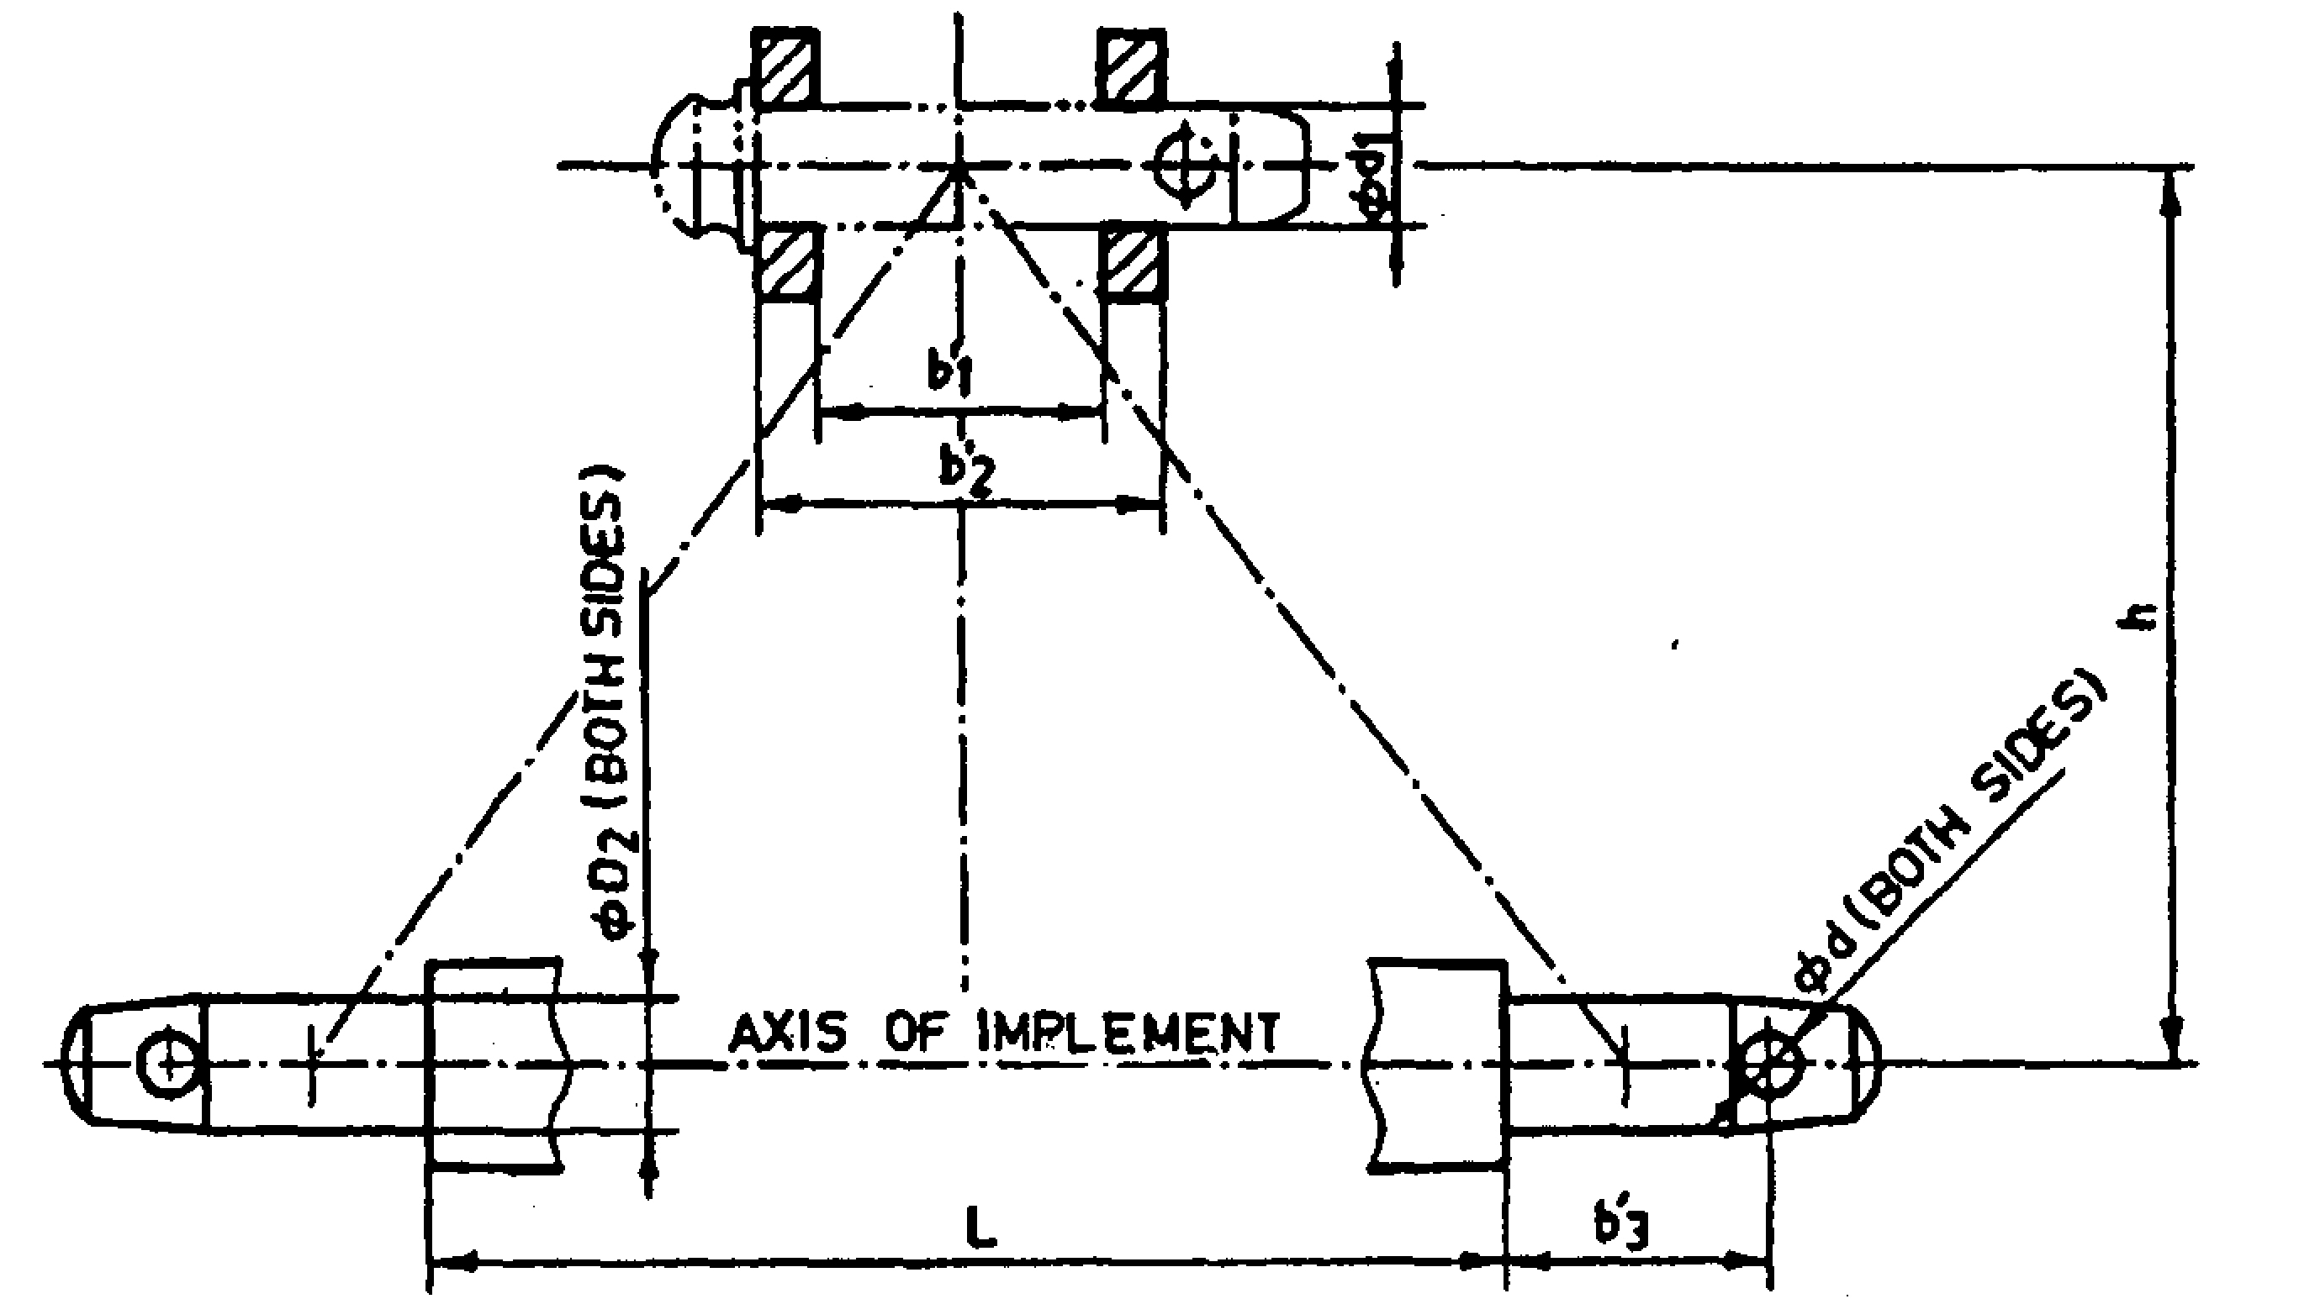
Fig. 1 : Implement Hitch Attachment
Specification of Hitch Pyramid As per IS: 4468-2001 (Part-I)

Sr. | Dimension  (Refer Fig.1) | Description | Measurement
Upper Hitch attachments
1 | d₁ | Diameter of hitch pin hole
2 | b’₁ | Width between inner faces of yoke
3 | b’₂ | Width between outer faces of yoke
Lower hitch points
4 | D₂ | Dia. of hitch pin
5 | b’₃ | Linch pin hole distance
6 | l | Lower hitch point span
Other dimensions
 | Diameter of linch pin hole
7 | d | For upper hitch pin
8 |  | For lower hitch pin
9 | h | Mast height

2.9 | Power transmission system:
 | a) |  | Method of transmission | :
 | b) |  | Type | :
 | c) |  | Number of teeth on drive sprockets | :
 | d) |  | Number of teeth on driven sprocket | :
 | e) |  | Speed ratio from drive to driven sprocket | :
 | f) |  | Speed (rpm) of pump corresponding to 540 rpm of the tractor | :
2.9.1 |  | Splined end of sprayer input shaft (Refer Fig. 2):
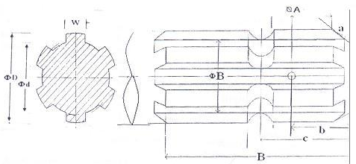
Fig. 2: Dimension of Implement Power Input Shaft
Dimension of Implement Power Input Shaft As per IS: 4931-2006
Specification/ Notations  (Refer Fig.2) | Measurement Dimensions (mm)
D Φ
d Φ
B Φ
A Φ
W
a
b
c
x
B
h

2.9.2 | Propeller shaft (Refer Fig. 3) |  | :
 | a) | Type and material | :
 | b) | Length of shaft (mm) | :
 | c) | Mass of shaft (kg) | :
 | d) | Provision for locking | :

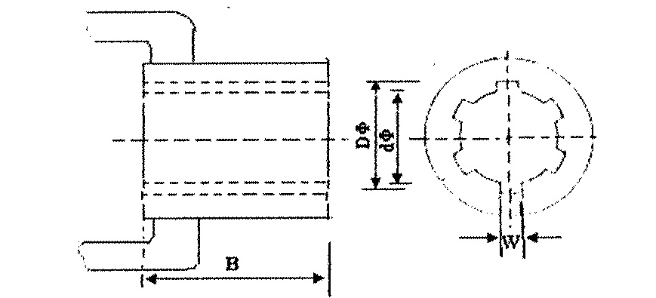
Fig. 3 : Propeller Shaft Insert Dimensions

Propeller Shaft Insert Dimensions As per IS: 4931-2006

Sr. | Notations(Refer Fig.3)
1 | D Φ
2 | d Φ
3 | W
4 | B

3 |  | Overall Dimensions (mm):
 |  | a) |  | Length |  | :
 |  | b) |  | Width |  | :
 |  | c) |  | Height |  | :
 |  | d) |  | Mass with all accessories and without chemical, (kg) |  | :
 |  | e) |  | Mass with all accessories and with chemical, (kg) |  | :
4 | Material used
Sr. No. |  |  | Components |  | Materials
1 |  |  | 2 |  | 3
1 |  |  | Pump cylinder
2 |  |  | Pressure chamber
3 |  |  | Piston rod
4 |  |  | Piston or plunger
5 |  |  | Spreader
6 |  |  | Valve assembly
7 |  |  | Roller pump shaft
8 |  |  | Pimp rollers
9 |  |  | Pressure regulator
10 |  |  | Suction strainer
11 |  |  | Strainer body
12 |  |  | Gasket
13 |  |  | Spray nozzles
14 |  |  | Spray boom
15 |  |  | Hose
16 |  |  | Tank
17 |  |  | Pipe for agitator
18 |  |  | Piston (bucket) screw
19 |  |  | Crank case
20 |  |  | Roller pump body
21 |  |  | Roller pump and plate
22 |  |  | Roller pump motor
23 |  |  | Piston pump crank shaft
24 |  |  | Pump inlet port end fitting
25 |  |  | Piston rod guide
26 |  |  | Connecting rod
27 |  |  | Gudgeon pin
28 |  |  | Big end bearing
29 |  |  | Small end bush

5 | Declaration:

Sr. | Particulars | Declared
1 | Recommended PTO speed (rpm), Pump speed (rpm) and Pressure (bar or kPa or kg/sq.cm.)
2 | Max. Achievable pressure (bar or kPA or kg/sq.cm.)
3 | Discharge rate (l/min)and spray angle of the nozzle / spray gun (degree)
4 | Tank capacity (lit)
5 | Is parts catalogue and manual giving detailed information about sprayer, engine, its rated speed along with operational and maintenance instructions and safety precautions provided? | Yes / No
6 | IS a set of necessary tools, suction strainer having aperture size of 300 µm to 425 µm and a measuring jar for lubricating oil provided? | Yes / No
7 | Is marking done on Spray gun as
7 | a) Manufacturer’s name or recognized trade-mark, | Yes / No
7 | b) Batch or Code number | Yes / No
8 | Is marking done sprayer as
8 | a) Manufacturer’s name or recognized trade-mark, | Yes / No
8 | b) Batch or Code number | Yes / No

Place:
Date: Signature : _____________________
Name : _____________________
Designation: _____________________

